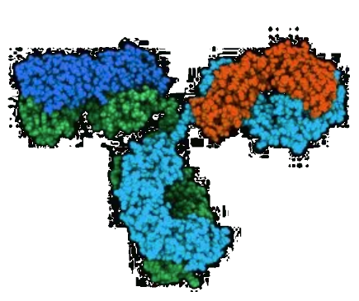
Project description

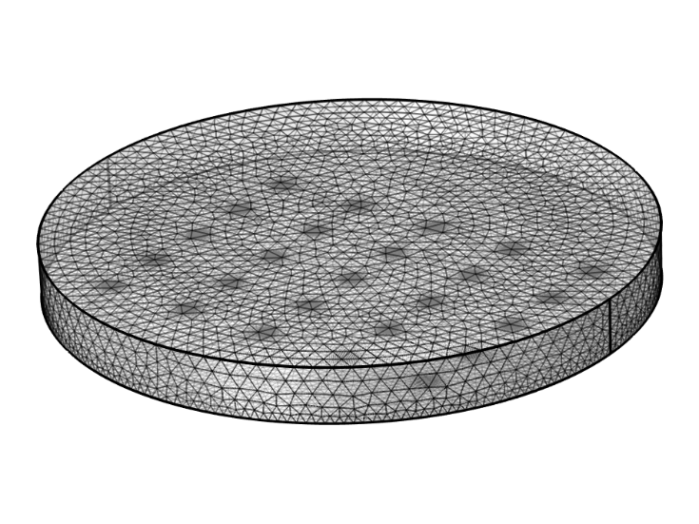
Tutor: Prof. Luca Selmi (luca.selmi@unimore.it)
Italian Co-tutor(s): Ing. Jacopo Nicolini
Title: Label free biosensing with nano-electronic devices and circuits

Keywords: biosensing, environmental sensing, high frequency capacitance spectroscopy, nanoscale detection and imaging, label-free sensing

Research objectives:
CMOS-based micro and nanoelectrode array biosensors represent powerful platforms for high sensitivity detection of small biomolecules and imaging of cells, of great interest for compact, low-power, high sensitivity devices amenable to large scale deployment [1,2]. Combined with on-chip capacitance/impedance spectroscopy measurements, this technology can be used to fingerprint analytes and enable purely electrical, label free, massively parallel, real time detection capabilities, remarkably reducing the sample consumption, time and cost of test for a variety of precision medicine applications. Until now, most of the work has been carried out on model systems of the analytes such as micro/nanoparticles, oil droplets, etc.
The key objective of this PhD is to demonstrate a breakthrough forward leap of this technology into the realm of cell imaging beyond the membrante and that of small biomolecules and biomarkers, down to nucleic acids, proteins, viruses.

Proposed research activity:
The research comprises, experimental, modelling and simulation activities. Firstly, experimental setup enhancements and sample preparation protocols will be identified to enable selective detection of DNA strands, proteins, viruses, down to single molecule level where possible, and to improve capacitive imaging of cell cytoplasm. Modelling and simulation tools (ENBIOS [3], COMSOL) will be extensively used to investigate optimum operating frequencies and to predict the expected molecule/cell fingerprints. The experiments will aim at high-frequency operation (a condition that remarkably mitigates the Debye screening effects that limit the sensitivity in physiological electrolytes. In a second phase, an advanced biosensor chip featuring massively parallel (about 65000 pixels) nanoelectrode (180 nm) array with real time imaging capabilities and multifrequency operation will be used to carry out an extended campaign of measurements up to above 200 MHz frequency, in order to acquire extensive statistics [4]. The data will be carefully scrutinized with Bayesian and ML algorithms and compared to simulations in order to validate the protocols and the models for reliable sensing of the different analytes [5].

Supporting research projects (and Department)
The activity will be carried out mostly at the DIEF, Università di Modena e Reggio Emilia.

Possible connections with research groups, companies, universities.
Delft University (NL)
ETH Zurich (CH – sensing platform operation)
IUNET Research Consortium (IT - www.iunet.info)

Essential bibliography:
[1] F.Widdershoven et al., DOI: 10.1109/TBCAS.2018.2861558
[2] C.Laborde et al., Nature Nanotechnology, vol. 10, no. 9, pp. 791–795, 2015.
[3] F.Pittino et al., CMAME, pp. 902–923, 2014
[4] A.Cossettini et a., https://dx.doi.org/10.1109/SENSORS47125.2020.9278583
[5] D.Stadbauer et al., https://dx.doi.org/10.1016/j.jcp.2019.108874

